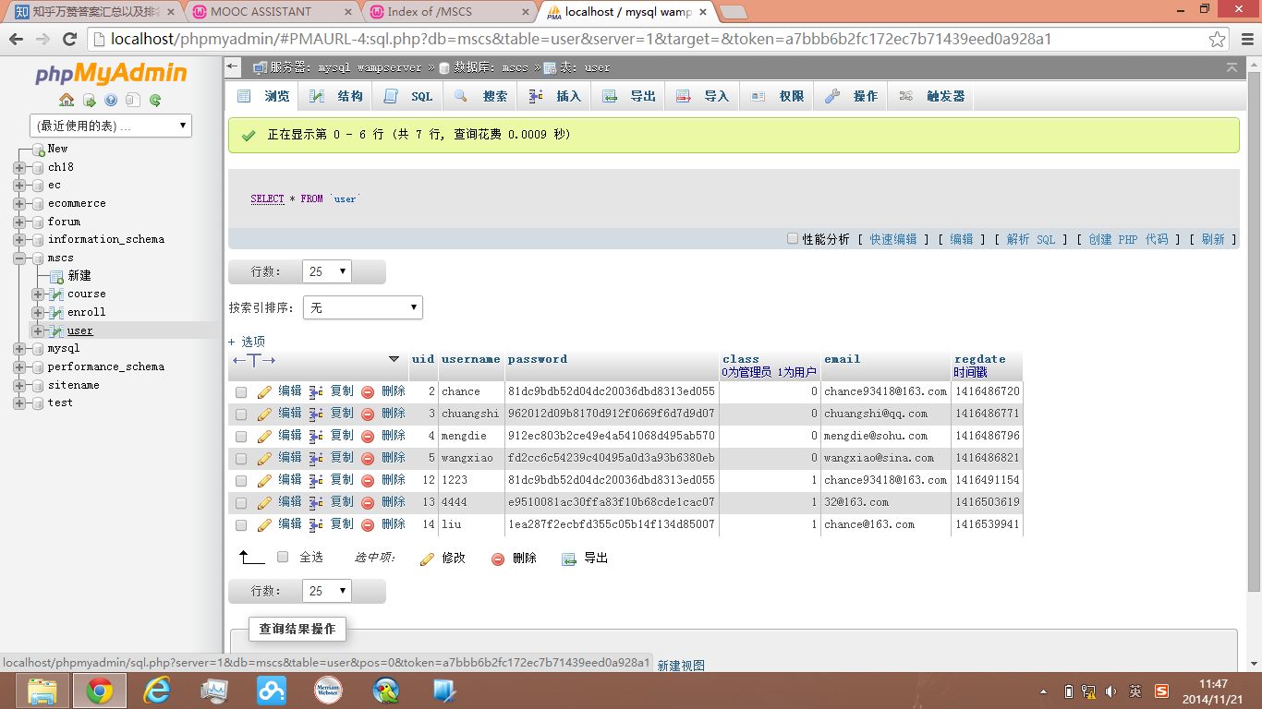

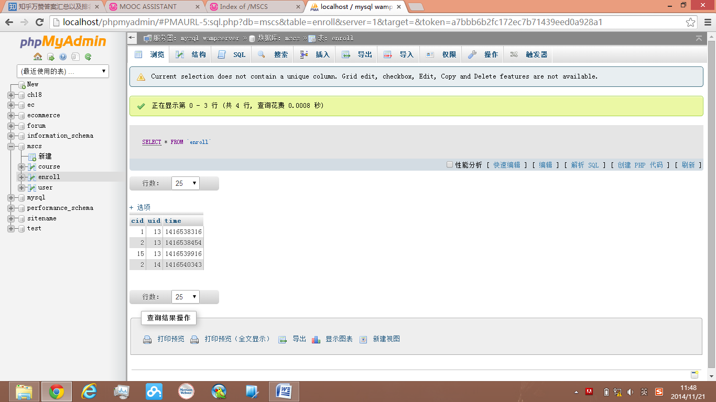

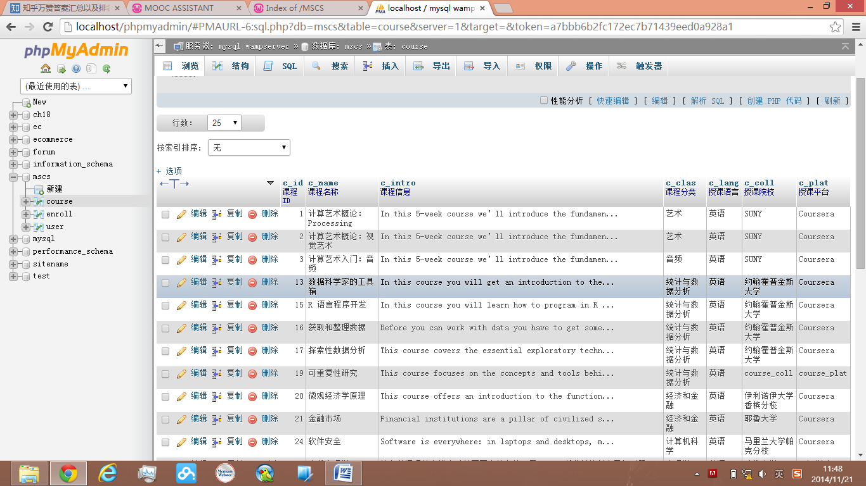

<?php # Script 18.4 - mysqli_connect.php

// This file contains the database access information.

// This file also establishes a connection to MySQL

// and selects the database.

// Set the database access information as constants:

$db_host="localhost"; //连接的服务器地址

$db_user="chance"; //连接数据库的用户名

$db_psw="PHjGCBVpPb53Zxzz"; //连接数据库的密码

$db_name="mscs";

$db_conn;

// Make the connection:

//$dbc = @mysqli_connect (DB_HOST, DB_USER, DB_PASSWORD, DB_NAME);

$mysqli=new mysqli();

$mysqli->connect($db_host,$db_user,$db_psw,$db_name);

// If no connection could be made, trigger an error:

if (!$mysqli) {

trigger_error ('Could not connect to MySQL: ' . mysqli_connect_error() );

} else { // Otherwise, set the encoding:

mysqli_set_charset($mysqli, 'utf8');

//echo '连接成功';

}

if(!isset($_SESSION['userid'])){

echo '您尚未登录，即将跳转到登录页面';

echo '<META HTTP-EQUIV="Refresh" CONTENT="2; URL=Login_V.php">';

exit();

}else

{

$uid = $_SESSION['userid'];

$username = $_SESSION['username'];

}

if(!isset($_POST['enroll']))

{

echo '非法的请求，即将返回选课列表';

echo '<META HTTP-EQUIV="Refresh" CONTENT="2; URL=ShowCourse.php">';

return;

}

table{

table-layout: fixed;

}